🔁 Loop Controller in JMeter



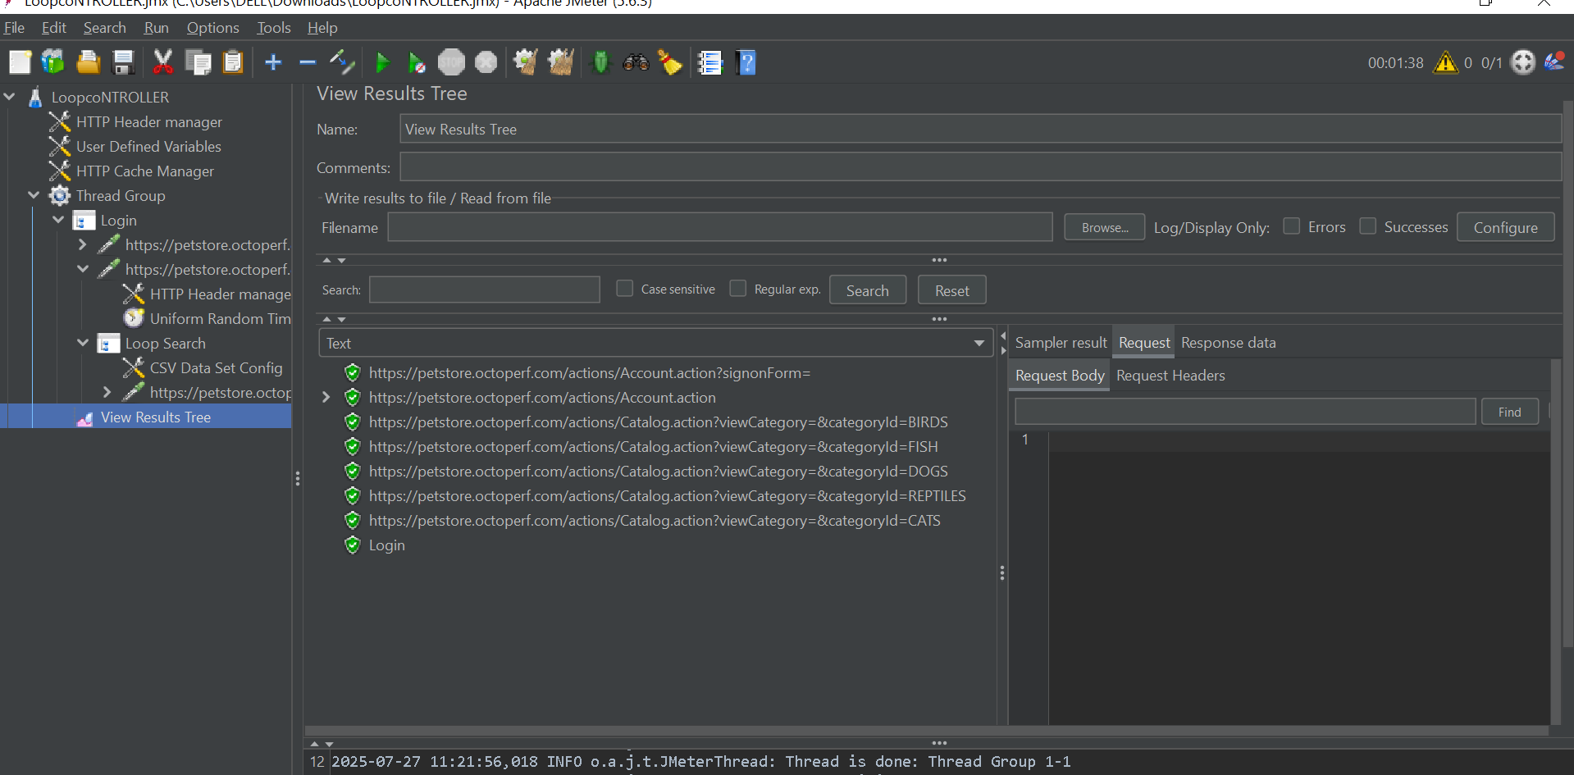

**📌 What Is It?**

The **Loop Controller** is a **Logic Controller** in JMeter that enables **repeating a set of actions** (samplers or other elements) a specific number of times or indefinitely.

**⚙️ Configuration Steps**

1. **Add a Thread Group**  
   Right-click on Test Plan → Add → Threads (Users) → Thread Group
2. **Add a Loop Controller**  
   Right-click on Thread Group → Add → Logic Controller → Loop Controller
3. **Set Loop Count**
   * Positive Integer: Number of times to repeat.
   * Forever (check box or set -1): Infinite loop (use with Thread Group duration).
   * Variable: Use ${myLoopCount} or ${__P(loopIterations,10)} for dynamic values.
4. **Add Child Elements**  
   Add samplers (e.g., HTTP Requests) or other logic/controllers inside the Loop Controller.

**🔄 Behavior of Nested Loops**

If:

* Thread Group Loop Count = X
* Loop Controller Count = Y

Then the **child elements** inside Loop Controller will run **X × Y times**.

**✅ Common Use Cases**

| **Use Case** | **Description** |
| --- | --- |
| **Simulate User Behavior** | Repeating searches, adding items to cart, pagination |
| **Data-Driven Testing** | Iterate over data from a CSV file |
| **Stress Testing** | Repeatedly hit an endpoint |
| **Functional Testing** | Re-run scenarios for stability verification |
| **Controlled Repetitions** | Run a specific part of the test a fixed number of times |

**📘 Example Scenario**

Simulate a user who:

* Logs in
* Performs 3 searches (repeated 3 times)
* Logs out

**Structure:**

pgsql

CopyEdit

Test Plan

└── Thread Group (Threads: 10, Loop Count: 1)

├── HTTP Request (Login)

├── Loop Controller (Loop Count: 3)

│ ├── HTTP Request (Search 1)

│ ├── HTTP Request (Search 2)

│ └── HTTP Request (Search 3)

└── HTTP Request (Logout)

**Result:**

* 10 users simulated
* Each user sends:
  + 1 Login request
  + 9 Search requests (3 searches × 3 loop count)
  + 1 Logout request
* **Total:** 10 logins + 90 searches + 10 logouts

**🧠 Pro Tip**

Use Loop Controller with CSV Data Set Config to iterate through test data. It enables powerful **parameterized testing**.